3rd Annual Denim & Pearls Fundraising Dinner
2017
2017

Sponsorship Opportunities
http://lancastercountyagweek.com

In Celebration of Lancaster County Agriculture!
“Put away the suits and stilettos and break out the denim and pearls for a 5-star dinner down on the farm!
A dinner featuring the best Lancaster County has to offer…prepared by The Restaurant at Oregon Dairy.
From the delicious hors d’oeuvres & beverages to the amazing entrees & desserts,
Come Celebrate Lancaster County’s Homegrown Goodness!”

Each year, the Denim & Pearls Dinner on the Farm is featured at a different Lancaster County Barn venue. This year the event will be held at the beautiful Stoltzfus Homestead & Gardens in Gordonville, PA. This event is a fundraising dinner for The Lancaster County Agriculture Council and all of the courses prepared that evening feature products that are made, grown and/or produced in Lancaster County, PA.

Guests purchase tickets to attend the event. Tickets are $75/person and can be purchased online at: https://www.oregondairy.com/entertaining-catering/denim-pearls-dinner. Guests are encouraged to wear denim & pearls and the guests all receive a gift bag featuring Lancaster County made products.

Denim and Pearls Partner
Sponsorship will be used to provide Lancaster-grown foods for this moderately upscale farm-to-fork dinner event at the Stoltzfus Homestead & Gardens, Gordonville, on Wednesday, October 11th.
- Sponsor logo will be on the Ag Week website from now until Spring 2018
- Sponsorship will include 4 tickets to Denim and Pearls
- Opportunity to hand out promotional or marketing materials at Ag Week events
- Primary recognition on a display at Denim and Pearls

Investment $500

Denim and Pearls Supporter
Sponsorship will be used to provide Lancaster-grown foods for this moderately upscale farm-to-fork dinner event at Stoltzfus Homestead & Gardens, Gordonville, on Wednesday, October 11th.
- Sponsor logo will be on the Ag Week website from now until Spring 2018
- Sponsorship will include 2 tickets to Denim and Pearls
- Small font logo recognition on a display at Denim and Pearls

Investment $250

To accept a sponsorship as outlined above, please complete the following; mail to Amber Good at P.O. 475, Lititz, PA 17543
or scan/email to Shelly Dehoff at shellydehoff@lancasterconservation.org. Contact Shelly at 717-880-0848 or by email with questions.

Indicate sponsorship package title here: _____________________________________________________________

Name:________________________________________ Company:_____________________________________

Phone Number:__________________________________ Email:__________________________________________

Signature:_________________________________________________ Date: _______________________________
The Lancaster County Agriculture Council sincerely appreciates your investment in our efforts to tell the positive story of agriculture. Investments are non-refundable.

In celebration of Lancaster County Ag Week, October 8 - 14, 2017, we will be hosting the 3rd Annual Denim & Pearls “Farm to Fork” 5-star meal, featuring all Lancaster County produced products on Wednesday, October 11, 2017 at Stoltzfus Homestead & Gardens in Gordonville, PA.
For the Denim & Pearls meal, we would like to give all the guests a gift bag featuring all Lancaster County produced products. We are looking for 150 items for the gift bags, anything from a sample or single serve size of your product to brochures, postcards or promotional items. We are also giving away door prizes throughout the evening and would love for our guests to have a chance at winning your Lancaster County made product. Your business name will be posted on our website, the Lancaster County Agriculture Council’s website and it will be posted along with your product the night of the event. To participate, please complete the information below and return to Nancy Brown at nancy.brown@oregondairy.com
Name of Business:
Contact Person: Phone Number:
Donation of product for Denim & Pearls Gift Bag – need 150 Items Yes No
Name of Item Donated:
Donation of door prize for Denim & Pearls Guests: Yes No
Name of Item Donated:
Items for gift bags and door prizes are needed by Monday, October 9, 2017 at the latest.
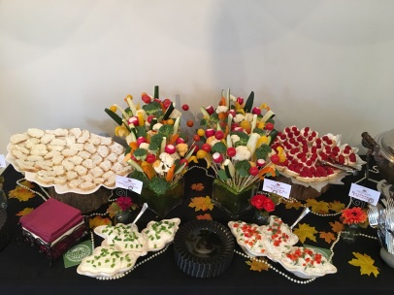
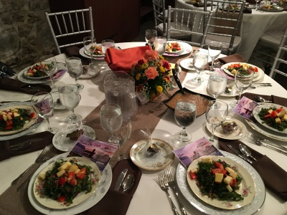
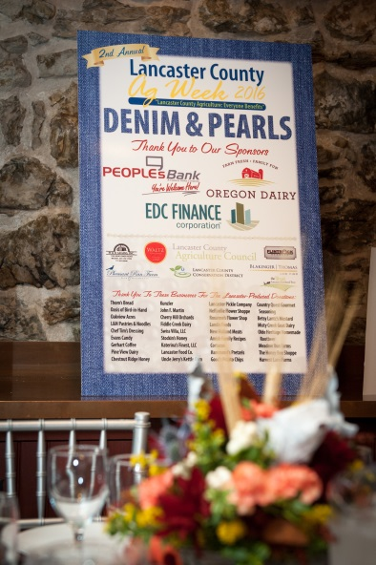
Here are some images from last year’s Denim & Pearls Dinner.

